# Progress Update III

## Frontend Status

The front for the application is complete. Along with firebase connectivity it responding to real time changes. As discussed, we are in the progress of changing our technology stack from Flutter/Dart to Java for android. Some buffer time allotted will be utilized in this aspect as I source out the right person for the job. Since time is of the essence, we will be dealing with feedback along with report documentation.

## Backend Status

Backend for the application is in its deployment stage. It is deployed on to Heroku as a Flask application and the front with connected with just the database instead of relying responses from backend APIs. Since, this will be a serverless application, response/replies will be written to the database which in turn will be fetched by the application in real time. Every time a user adds/removes something from their likes list 2 APIs content based filtering and collaborative based filtering will be called which will populate the users’ recommendations list according in Firebase and these will then be fetched by the frontend application. The backend for the application can be visited by clicking [here](https://skincare-recommendation-app.herokuapp.com/). This is just the template for Flask on a windows server, the APIs are active and can be reached with a specific URL that will be defined in the application frontend and its documentation.

## Testing Status

After the integration is complete, we will be entering a testing phase where feedback and issue will be our sole priority. The scope of this phase will rely on testing features, their responses and requirements matching.

## Project Board

The project board has been updated with major changes with all the requirements that have been accomplished pushed to the ‘Done’ column and the current features in the ‘To-Do’ status, and features that require validation are being held off in the ‘Read for QA’ section. Please feel free to visit the board after you verify your account in the private repository. Attached is a snap shot for quick reference.

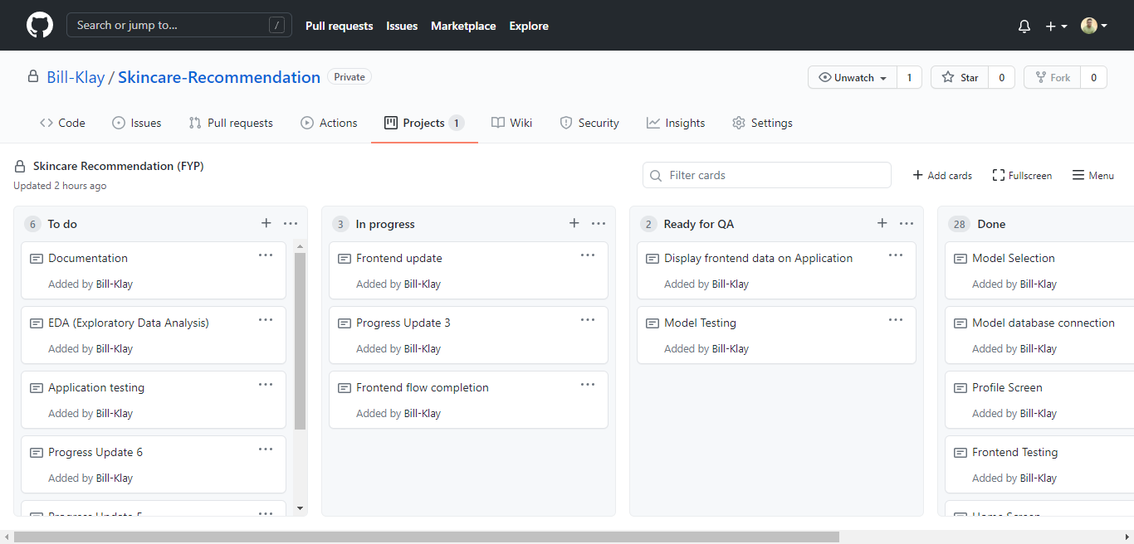

## Attachments

The attachments for this progress update contain the source code for the backend application. Please note that there are multiple header/library files required to execute this in a certain environment which can be found in the requirements.txt file. Plus, a notebook has been attached which defines the step taken for prototyping and setting a POC for the work accomplished. The SQL file has all the necessary steps taken to achieve the source data in its current form after sourcing and scrapping it from multiple websites. The excel files attached are what have been used for analysis through the project so far, with the user reviews and their characteristics in the reviews file and all the product related data in the products sheet.

